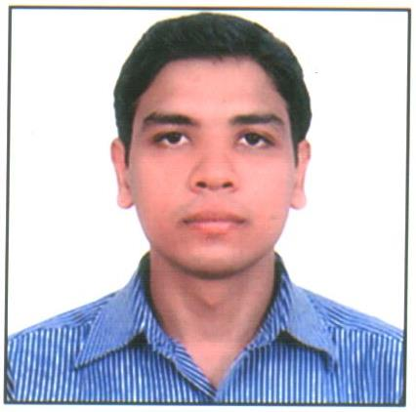 PANKAJ KUMAR

Address: Mahaveerji Nagar Fazalpur,
Rohta Road Meerut,
Distt. Meerut (U.P.)
E-Mail Id: pankajvansh.28@gmail.com,
Mobile: 09634304969, 09058434309

Objective
I intend to build my career with a leading company of Hi-tech environment with committed and dedicated staff, which will help me to explore my potential and realize my qualities. I am willing to work as a team member in challenging and creative environment.

Professional Qualification

Master of Business Administration (MBA) - (Specialization- HR)

MICI, Meerut affiliated to Punjab Technical University, Jalandhar with 75.72% in the year 2012.

Bachelor of Science (B.Sc)

Dev Nagri Degree College Meerut affiliated to Chaudhary Charan Singh University, Meerut with 56.2% in the year 2009.

Academic Qualification

Intermediate C.A.B Inter College, Meerut affiliated to U.P. Board in 2006.

High School C.A.B Inter College, Meerut affiliated to U.P. Board in 2004.

Computer Diploma
(PDWSE) Professional Diploma in web Software Engineering.
Languages C, C++, HTML
Operating System DOS, Window 98/XP.
Other Packages MS Office, Internet.

Experience
1). Updater Services Pvt. Ltd. (2014 – Till Date)
Worked as an HR (Administration) to facilitate Income tax department in dealing day to day activity to achieve their organization goal. Broad prospective in which I have worked are following:
- Identifying and meeting the training needs of existing staff
- Ensuring employee welfare and employee relations are positive
- Ensure the working environment is safe for employees
- Raising awareness of current workplace.
2). Shivangi International, Meerut (2010 – 2014)
Worked as an Administration office operations so as to facilitate proper Record Maintenance with the Allocation of huge set of emails and guided reply to the customers for International business of the company.
Responsible for regular maintenance and functioning of the computer systems and network.

3). N.A.S. Degree College, Meerut (2009 – 2010)
Worked as an office Clerk.

Soft Skills Punctual, Soft Spoken, Quick Learner, Helpful, Honest, Trustworthy, Hard Worker.

Hobbies Singing and Playing Cricket.

Personal Detail

Name Pankaj Kumar
Date of Birth Sep 29, 1988
Gender Male
Father’s Name Shri. Bhushan
Nationality Indian
Marital Status Married
Languages known English, Hindi

Declaration I hereby declare that the above stated facts are true to the best of my knowledge and belief.

Date: - / /2016 (Pankaj Kumar)

